**CONFIGURING PULSE SECURE AND INSTALLING IBMi ACCESS CLIENT SOLUTIONS**

**CONNECTING PULSE SECURE**

**Step 1:** Open Pulse secure and add (+) below URL

<https://iras.costco.co.uk/UST>

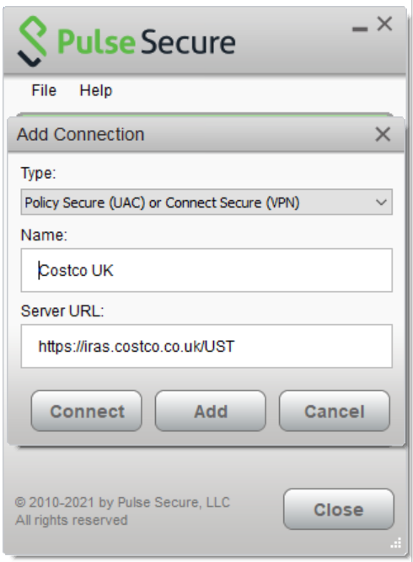

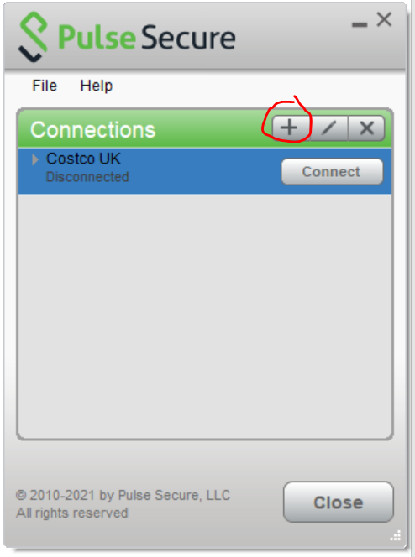

**Step 2:** Click connect and enter your Lan ID and Password

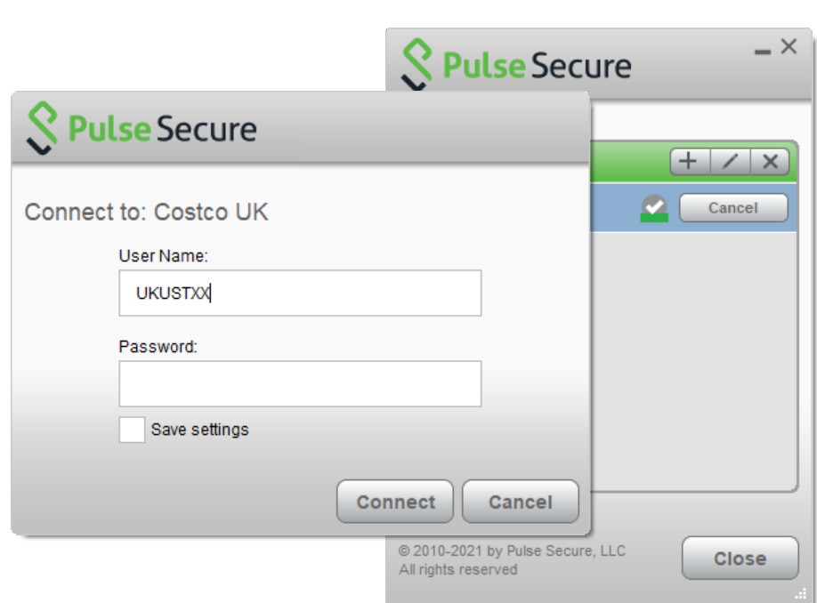

**Step 3:** Now enter your Secondary username and Secondary password and connect.

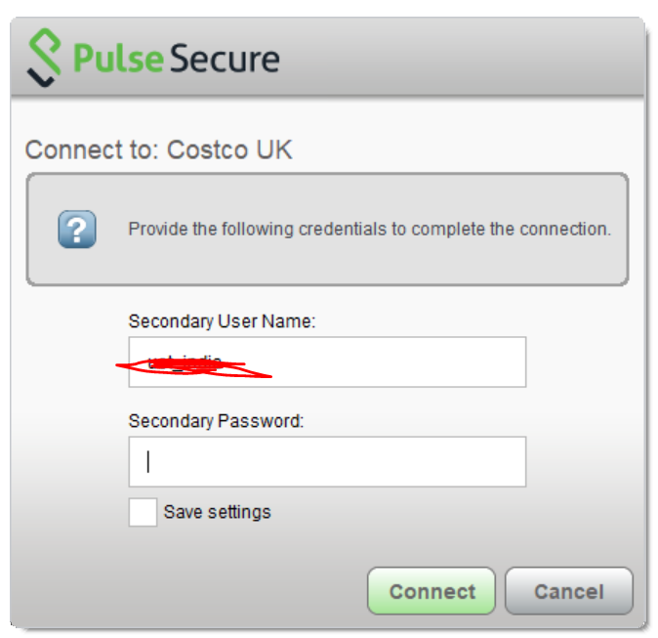

Now pulse secure connection is completed

**INSTALLING IBMi ACCESS CLIENT SOLUTIONS**

**Step 1:** Download IBMiAccess Zip file

**Step 2:** Unzip and follow the instalation process. For Windows below are the steps.

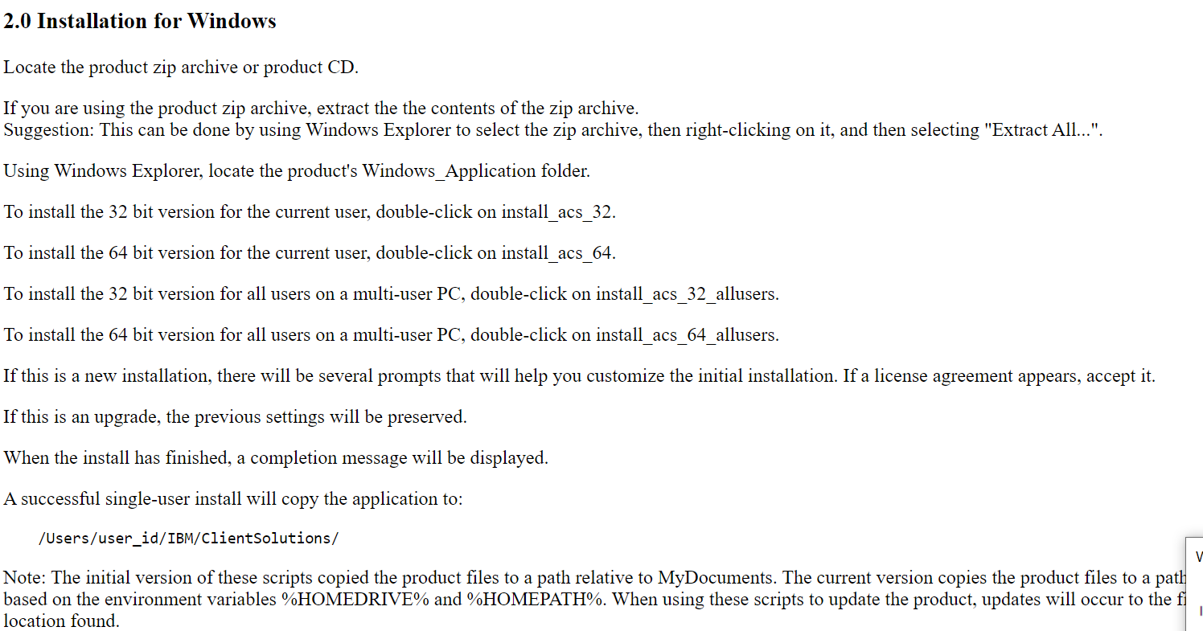

For Linux/Mac see instruction in the extracted folder.

**Step 3:** Select right file of installation (Say Windows 64) and proceed by giving Yes to all prompts and accepting license agreement.

**Step 4:** In case you are getting below error after installation, an ISolve ticket needs to be created to install right version of Java

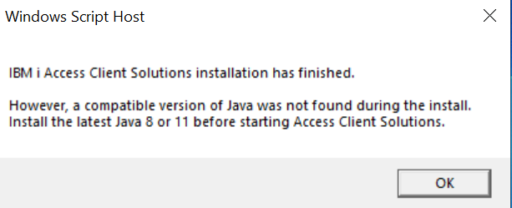

**STEP 5:** After successful installation below icons will appear on desktop. Now open Access Client Solutions

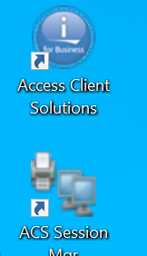

**Step 6:** Open 5250 Session Manager

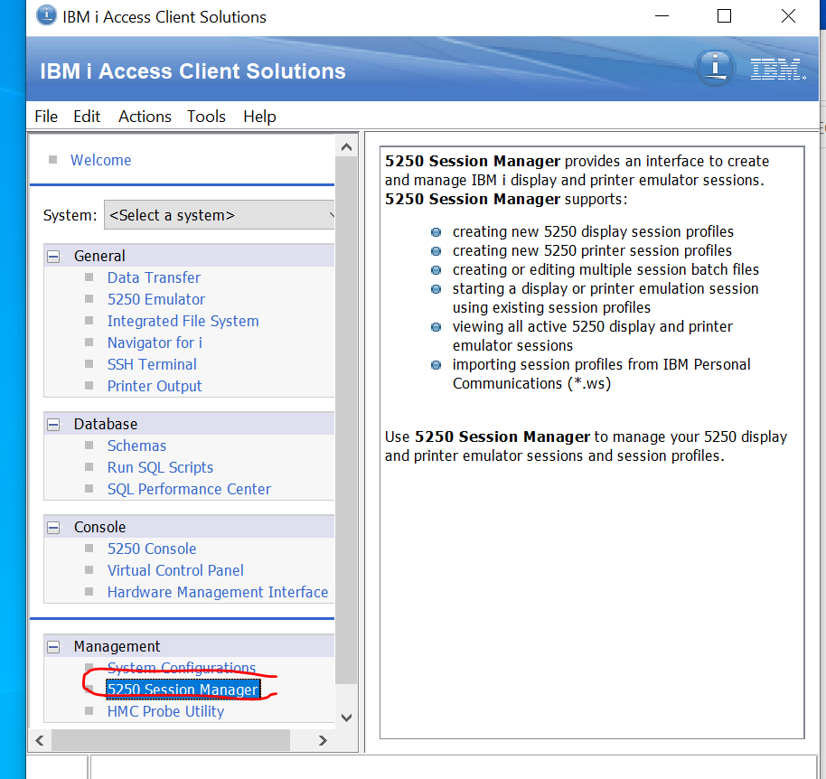

**Step 7**: Open New Display Session

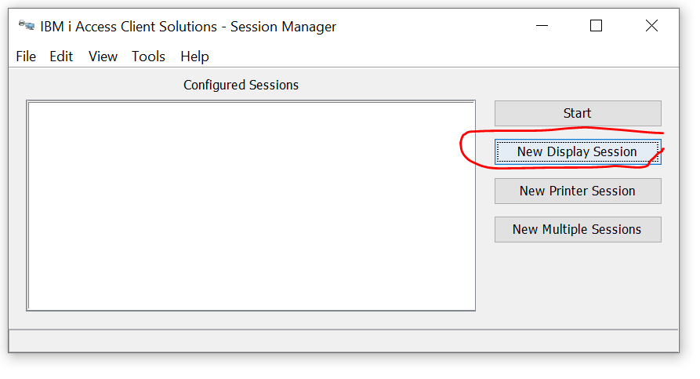

**Step 7**: Give parameters as below

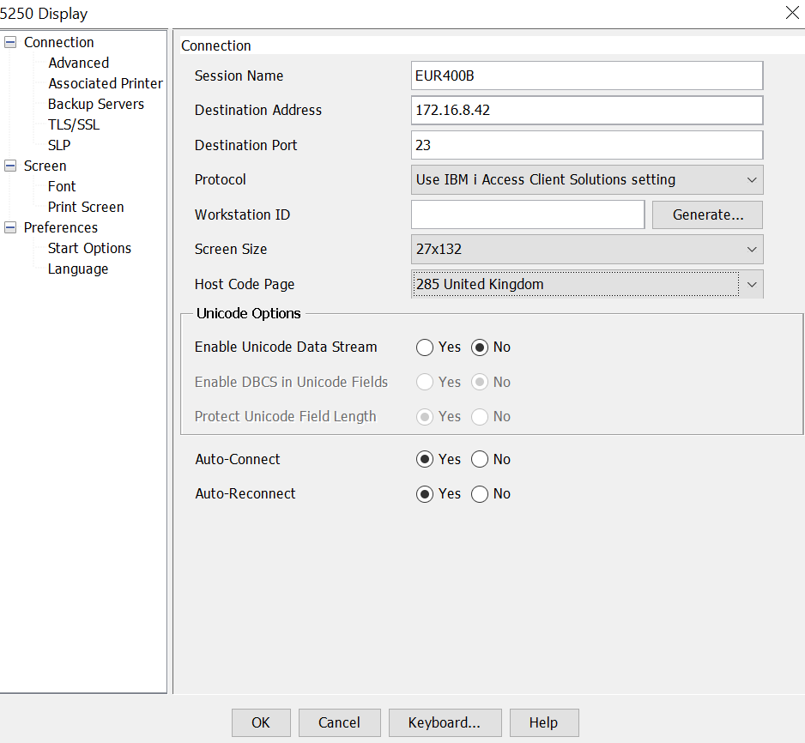

**Step 8**: Enter AS400 Credentials

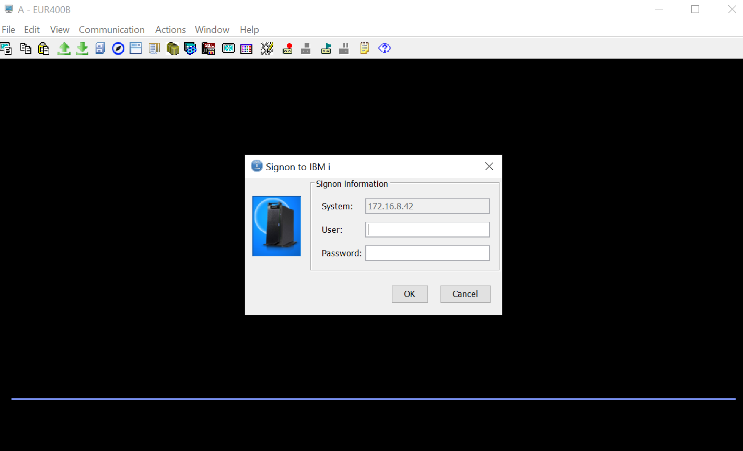

**Step 9**: Enter AS400 Credentials again – Save sessions as needed.

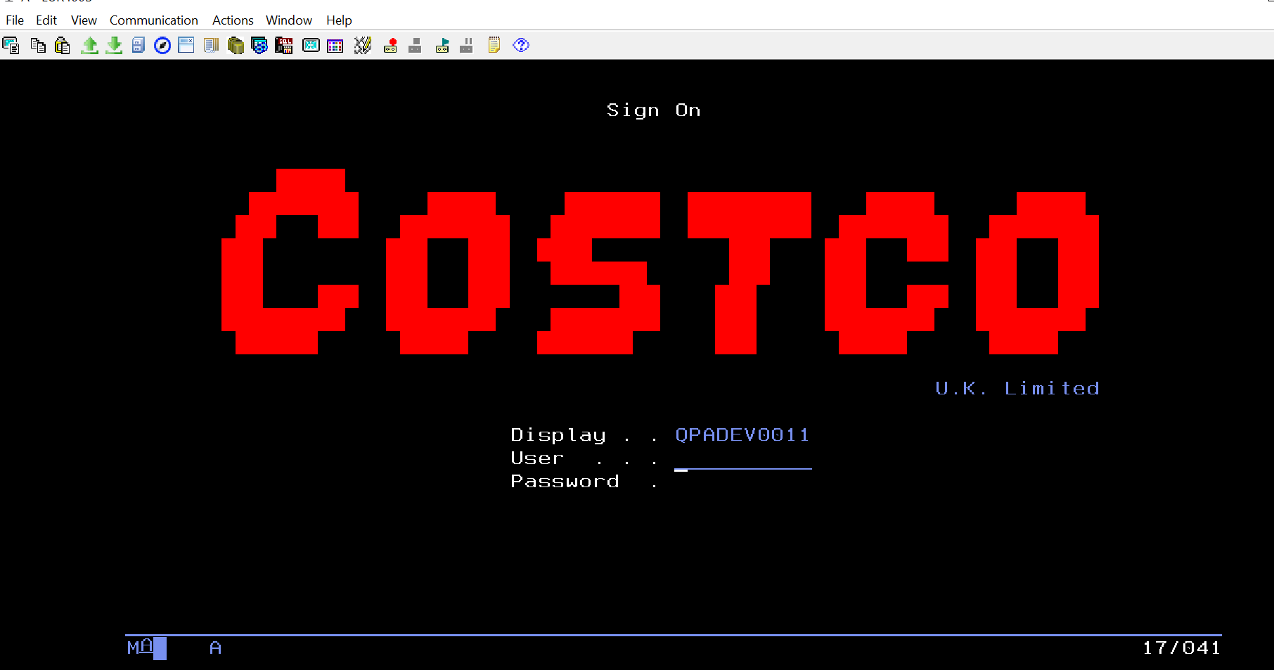

Happy Coding!!!